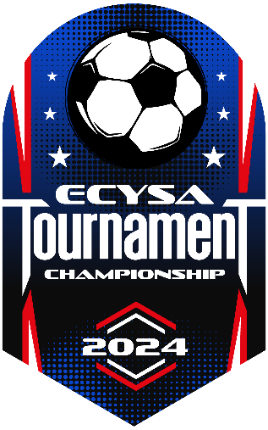

Playoff Coaches Information 2024

Congratulations to all teams that have qualified to participate in the 2024 ECYSA Championship Tournament. Each of your teams has already had a very successful season. Please be sure your online contact information is correct so that we can reach you in case of an emergency or schedule change.

LOGISTICS:
- Tournament Dates: Monday June 10 – Sunday, June 16th, 2024
- EARLY CONFLICTS SCHEDULE: Some games may be played on Sunday and Monday because teams have conflicts with school events during the week.
- Schedule: Posted online (ecysa.org) and subject to change. Please double check it after each match.
- Tournament Sites: Please be sure all of your families know that not all games are played at Pingree School. The ECYSA Tournament has multiple sites leading up to the Semi-Finals and Finals on Saturday and Sunday.
Hamilton/Wenham (Iron Rail Field #8A, #8B, #9)
Hamilton (Pingree School Field #1, #2, #3, #4, # 5, #6)

PLEASE, NO PETS AT THE FACILITIES!
NO SMOKING or TOBACCO PRODUCTS or VAPING of any kind at any ECYSA Tournament Game or Facility

- Parking: Parking varies by facility. Please respect the parking attendants at the respective facilities, they are volunteers. There are handicap spaces available at the Pingree School please see details below. The main entry to the school is a ONE WAY. Please advise spectators of such!!!
- LIMITED PARKING on the LEFT SIDE OF THE ENTRY ROAD at Pingree School! Used primarily for those with games at Field #1.
- Handicap transport onto the playing fields is available by request at the registration tent or through the parking attendants. Handicap parking will also be available in the small lot by the front of the school.
- FIELD #6 - If you have a game on Pingree Field 6 – let your parents know to drive to the lot in the rear of the school which is adjacent to the field.

- Arrival Procedure: Arrive 30 minutes before your game. Only Head or Assistant coaches
need to check-in at the site registration tent where you will receive instructions and be directed to your field. Proceed to your designated field, player’s game ready, for equipment/roster check-in with the referee staff. You will receive Tournament Patches at your first check in. You must check in for each game. You must have your ECYSA coaches credential and MA Youth Soccer Credential along with all player photo roster when you check in.

- Post Game: If your team advances it is good practice to check in at the main tent on your way out to be sure the schedule or location for your next game has not been changed.

REFEREE: In most cases ECYSA will be providing a Center Referee and two Assistant Referees (ARs) for each game. Coaches and players may not be used to this in the G6 and G8 age groups, but it is a system that provides the best possible coverage for each game. As a coach, simply understand the Center Referee is in charge of the game the same way that he or she is when you only have a single referee.

TRAINERS: We will provide professional athletic trainers for each venue. They will be there to assist in caring for injuries and they will be the final say as to a player’s ability to return to play. At the Pingree site trainers will be in golf carts with Red Cross flags as markers.

FOOD: There will be food and water / Gatorade for sale at the Pingree site.

Overtime Procedure:
- 2 five minute OT periods – no golden goal (between OT periods, change sides, no break)
- If still tie – Penalty Kicks (PK)
- Each Coach will provide a list of five players, who finish the game on the field, to the referee by uniform number in order of the kicks to be taken. (Make your list by players uniform number in advance)
- An additional list of players should be provided for the balance of the team on the field in the order of kicks in case it is necessary to go beyond the initial five players.
- Team who wins the toss will decide if they want to kick first or second.
- If after the five designated kicks the score is still tie – then PKs proceed with the remaining players on the field, one kicker at a time until the tie is broken or everyone on the field has attempted one kick (including the keeper)
- If the score is still tie – then PK continue in any order determined by the coaches from the sideline. The second time through does not have to proceed in the same order.
- PK will continue, using only players who were on the field at the end of regulation play until the tie is broken.
- No player may kick an additional time until all other teammates including the keeper have attempted a PK in that particular round.

TOURNAMENT GEAR: This year our gear vendor Fine Designs is back to provid tournament gear both in the form of pre-orders and on site, made to order. The link to the online store:

https://store.finedesigns.com/newengland/2024-ecysa-championship-tournament.html

Championships and MTOC: We have 25 championships and 14 in the MTOC divisions along with wild cards for MTOC in G6 B – MTOC 2, G8 G – MTOC 1, and G10G MTOC 1. All champions will receive a championship T-shirt. All finalist will receive a tournament finalist T-Shirt. Champions in the MTOC 1 and MTOC 2 divisions qualify for the state tournament to be played on June 21-23 in Lancaster. All winners and wild cards should check in at the registration tent after their game to receive instructions for their time at MTOC.

Weather: In the event of Weather related issues (Thunder & Lightning) if you hear an air-horn sound, please calmly exit the playing surfaces to your vehicles and await further instructions from tournament officials. We will attempt to restart games when the storm clears. In a case where weather postpones a game, tournament officials will communicate a new schedule ASAP. Although our goal is to play all game to completion we reserve the right to adjust the length of games etc in order to complete the tournament.

Please enjoy your tournament experience and let us know if you have any questions.

Dean Sidell
President and Tournament Director

